Project Title: Return and Refund Analysis Dashboard
Business Domain: E-commerce
Tool Used: Power BI ,Excel
Author: Sreeram Sandhya Rani

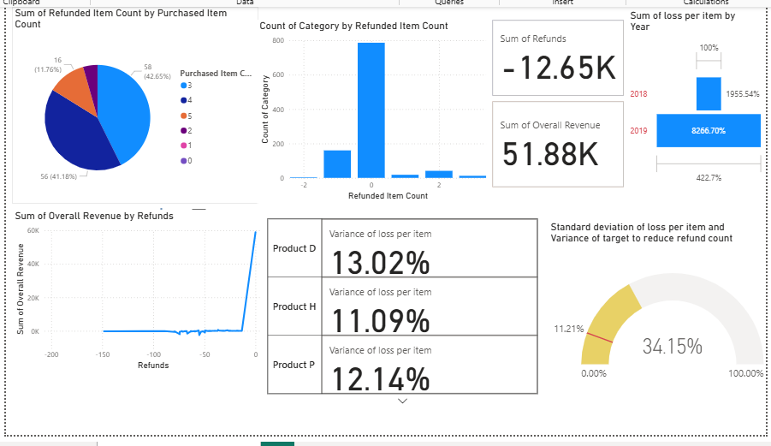

Step 1:
Objective
The primary objective of this Power BI dashboard is to analyze return and refund patterns in e-commerce transactions. By identifying trends, high-risk products, and customer behaviors, the dashboard helps reduce revenue loss and improve business decisions related to product quality.
Step2 :
Data Collection:
Collected the data set of E-commerce from the Kaggle website : https://www.kaggle.com/datasets/yaminh/product-sales-and-returns-dataset
Step 3:
Data Preparation :
Data organization:
- Organized the kaggle data set into Excel work book with comma delimiter.
- Transaction ID converted in to Hexagonal format to number format.
Data Cleaning :
- The total refund item count provided with proper count values.
- Total purchased items count provided with accordingly.
- Refund amount changed as per the refund items count change Used the formula : (Final Revenue / Purchased items count)* Refund items count .
- overall Revenue = Final Revenue + Refund + sales Tax

Step 4 :
Import Data to Power BI
Upload Excel file :
- Opened the Power BI application and created a blank report .
- Imported the cleaning data into the power BI model .
Build a Data Model :
- For the Refund and return analysis created only one Excel.
Step 5 :
Analyse Data.
Exploratory Analysis :
- Performed initial analysis , since only one item name in the dataset defined the refund against the product category.
Create Visulization :
- As per the initial analysis . created pychart against purchased items count vs refund items count .
- Prepared Tree chart against to year of the date. Compare to 2018 more items returned in 2019.
- Prepared cards for the sum of Overall Revenue and for sum of Refunds.
Predictive Analytics:
- Loss per item calculated as per the below DAX formula :
- loss per item = E_commerce_cleaning[Refunds]/E_commerce_cleaning[Overall Revenue]
- Targeted to reduce the refunds and returns by 50%
- target to reduce refund count = E_commerce_cleaning[Refunded Item Count] * 0.5

Worflows :
What is the total refund count
what is the total refund amount
Refund amount as per the year of the date
Refund amount as per the product category
Total refund count vs purchase count
based upon the items how many refunds
Total Revenue and Total Loss
Loss after refund

